Thomas Nguyen

COEN 160

Professor Mikkilineni

3/7/17

Exercise1.java (Traffic Light Implementation)

Default State:

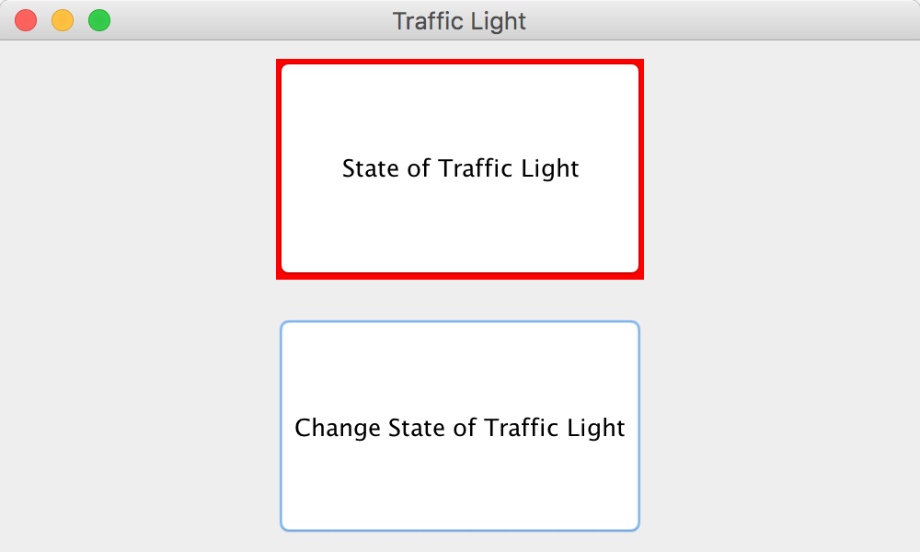

Press “Change State of Traffic Light”:

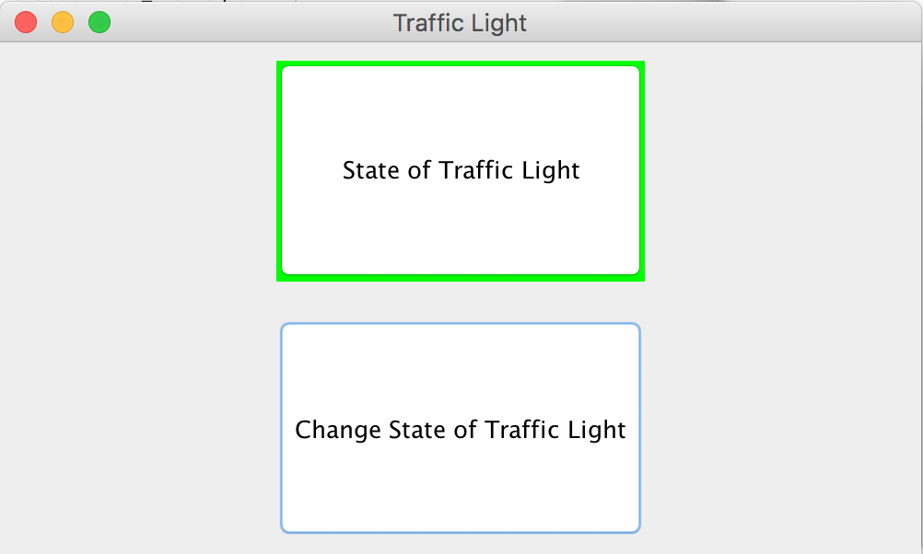

Press “Change State of Traffic Light”:

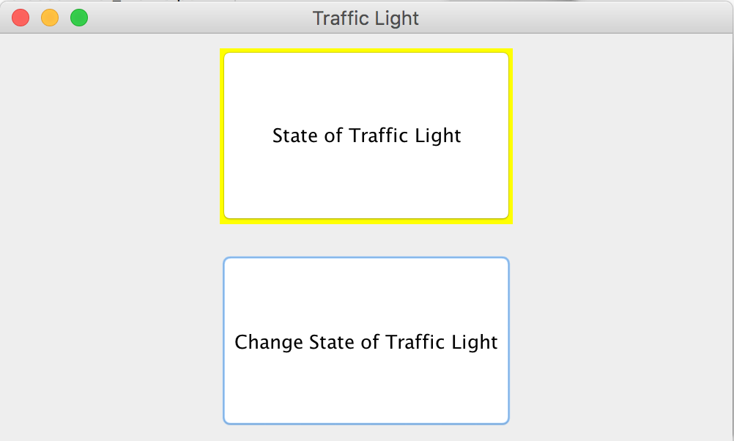

Press “Change State of Traffic Light”:



Exercise2.Java (Club & Club Member Implementation)

Default State:

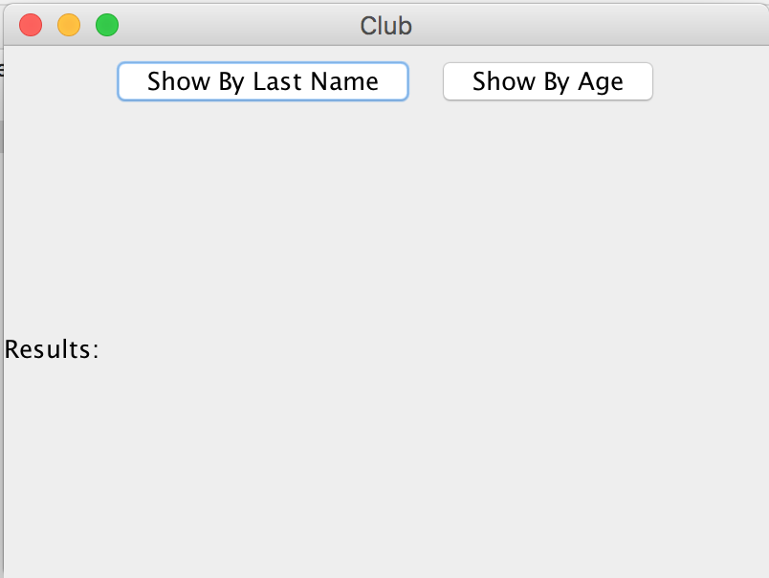

Press “Show By Last Name”:

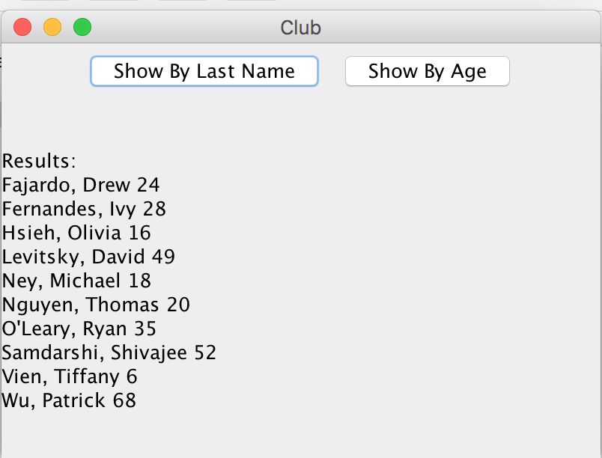

Press “Show By Age”:

